**Student No: S193825**

**Course: MSc Data Science and Artificial Intelligence**

**Module: Data Mining and Statistical AI**

**A technical report on video games future success with the use of machine learning prediction**

**TABLE OF CONTENTS**

1.0 Abstract....................................................................................................................................4

2.0 Introduction..............................................................................................................................5

3.0 Literature review......................................................................................................................6

4.0 Data collection, exploration, and visualisation.........................................................................9

5.0 Methodology..........................................................................................................................11

6.0 Results, discussions, and conclusions.....................................................................................13

7.0 Recommendations..................................................................................................................32

8.0 Conclusion..............................................................................................................................33

**TABLE OF FIGURES**

Figure1: Figure showing the descriptive data for the features of the dataset…………………………14

Figure2: Figure showing the mode for some features of the dataset……………………………………..14

Figure3: Figure showing the distribution of the year attribute……………………………………………….16

Figure4: Figure showing the distribution of the platform attribute………………………………………..16

Figure5: Figure showing the distribution of the publisher attribute……………………………………….17

Figure6: Figure showing the of all the features in the successful class…………………………………...17

Figure 7: Figure showing the of all the features in the unsuccessful class……………………………….18

Figure8: Figure showing the of all the features in the unsuccessful class………………………………..18

Figure9: Figure showing the correlation matrix before balancing…………………………………………..19

Figure10: Each feature against class correlation…………………………………………………………………….19

Figure11: Figure showing the class distribution of the data……………………………………………………20

Figure12: Figure showing the class distribution after subsampling…………………………………………21

Figure13: Figure showing the correlation matrix after subsampling……………………………………….21

Figure14: PCA of the dataset………………………………………………………………………………………………….22

Figure15: Learning curve for the Logistic Regression……………………………………………………………..23

Figure16: Learning curve for the K-Near Neighbor…………………………………………………………………23

Figure17: Learning curve for the Support Vector Classifier…………………………………………………….24

Figure18: Learning curve for the Decision Tree Classifier……………………………………………………….24

Figure19: ROC for all the classifiers………………………………………………………………………………………..25

Figure20: Under sampling precision-recall curve……………………………………………………………………26

Figure21 Oversampling precision-recall curve………………………………………………………………………..27

Figure22: The results of the model based on the class……………………………………………………………….27

Figure23: Confusion matrix for Logistic Regression…………………………………………………………………..28

Figure24: Confusion matrix for K-Near Neighbors……………………………………………………………………..28

Figure25: Confusion matrix for Support Vector Classifier………………………………………………………….29

Figure26: Confusion matrix for Decision Tree Classifier…………………………………………………………….29

Figure27 The result of the model for every classifier based on class…………………………………………30

Figure28 The accuracy score for the two balancing methods……………………………………………………31

**1. ABSTRACT**

The video game industry is a fast-growing industry, with video games influencing people's everyday lives around the world. Data mining techniques and models could help predict future video games' success based on datasets of past successful video games and observing trends and patterns. In this study, one such dataset was selected, explored, and visualized to help develop a data mining model that predicts the success of future video games. Based on the dataset selected, the research question for this study is if developers and publishers want their video games to succeed, what conditions does the video game have to respect. Since the video games would be grouped into classes, the research problem of this study would be in the context of the Data Mining and Statistical AI module, a classification problem. Therefore, the literature review would look over data-mining literature focusing on data mining problems in the video games industry. Most of the data mining problems found in the literature focused on the video games industry are either classification problems or clustering problems. In the case of this study, the data was collected from a dataset collection website called Kaggle.com. The data was initially collected by a video game analyst who compiled a dataset of videogames launched from 1980 to today. Being a classification problem, classification algorithms were used in the development of the study as the data mining methods of choice. The models resulting from those algorithms are later compared in terms of accuracy, precision, f1 score, and recall. These results would determine which classifier would have the most accurate prediction for the dataset. Finally, this study provides recommendations to future researchers and game developers. The recommendations account for the significant factors which will help to improve game predictions.

Keywords: Video games, data mining, classification, machine learning algorithms, successful and unsuccessful

**2. INTRODUCTION**

The video game industry is a fast-growing industry, with video games influencing people's everyday lives around the world. Almost every person has played a video game at some point in their lives, on personal computers, consoles, or even on their phones. Video games are the most lucrative entertainment industry today, making more than the other entertainment industries combined. For most, video games are entertainment and noting more. However, for some, video games are a way of entertainment and their livelihood. If developers and video game companies could predict how successful their video games would be, they would be at a considerable advantage against their competition. Data mining techniques and models could help predict future video games' success based on datasets of past successful video games and observing trends and patterns. In this study, one such dataset was selected, explored, and visualized to help develop a data mining model that predicts the success of future video games. Based on the dataset selected, the research question for this study is if developers and publishers want their video games to succeed, what conditions does the video game have to respect. The prediction results would put video games into two categories or classes: successful and unsuccessful. Because the video games would be grouped into classes, the research problem of this study would be in the context of the Data Mining and Statistical AI module, a classification problem.

**3. LITERATURE REVIEW**

As stated previously, the video game industry is a fast-growing market, and it is for some people their livelihoods. Thus, understanding and looking for methods and results from previous work in the literature would be a good step in the right direction. The literature review would look over data-mining literature focusing on data mining problems in the video games industry.

In their article, Kostas and Manolis (Anagnostou & Maragoudakis, 2009)proposed a player modeling based on "clustering of behavior data." (Anagnostou & Maragoudakis, 2009) The data was collected from player gameplay. The video game of choice for the research was a simple version of 'Alien Invasion.' The research aims to classify the players into two groups: the action and the tactical players. These predefined player types would help developers design video games with casual players in mind. The authors used clustering as a data mining technique because the data collected from player gameplay were not predefined (or labeled in a specific class). This means the research problem in the article was not a classification problem but a clustering problem. The data clustering was made possible due to the authors' choice in using the CURE algorithm in the methodology. The result from the K-means showed an error rate of 20% in the results. Despite a high error rate, the CURE algorithm grouped the two-player types into two different clusters, with the tactical player type having the most consistent out of the two. Unlike the dataset presented in the article, the one used in this research has labeled data, which contradicts the conditions of using clustering as a data mining method. With this in mind, clustering would be considered an option in this research's methodology phase.

Marcoux and Sid-Ahmed (Marcoux & Selouani, 2009) addressed an essential issue in the video games industry: sales forecasting. This issue is essential for video games companies and developers alike because it helps them make essential decisions that involve the development process and the marketing strategy for a potential game. Thus, it would help them with budgeting and forecasting profits. The method the authors proposed for the issue is a hybrid of a neural network framework called Autoregressive Time Delay Neural Networks, or AR-TDMN, and a pre-processing method based on Principal Component Analysis, or PCA, called Time Series Analysis, or TSA. This hybrid is focused on-time efficiency primarily because the dataset used in the article is enormous, thus requiring much time to process. Therefore, the data mining method proposed by the authors looks promising in terms of efficiency. However, neural network frameworks are outside of the module's curriculum. Also, the dataset used in this research is small, so it does not require efficient time frameworks. With all of these in mind, the hybrid method presented in the article would not be taken into consideration during the methodology phase of this research.

In their article, Araujo et al. (Araujo, et al., 2019) tried to solve a problem found in popular MOBA games. These games are essential because the games are played at a competitive level in championships called E-Sports. An efficient system that helps the player choose the best options based on recommendations would help the experienced players by spending less time in the customization menu before a match, and it would help the new players by allowing them to learn good combinations early, instead of using trial-and-error over hundreds of hours of gameplay. The dataset in the study is composed of data collected from thousands of matches across two continents. Being a classification problem, the machine learning algorithms used by the authors are those often found in these types of problems. Examples of machine learning algorithms used in the research are decision trees and logistical regression. Besides those, the authors also used artificial neural networks or ANN. ANN provides the best results. However, although ANN looked promising, it is outside the module's curriculum. Thus, it can not be considered during the methodology phase of this research. With this fact in mind, the best option available are the classic classification methods such as decision trees and logistical regression.

In their article, Fernandes et al. (Fernandes, et al., 2021) studied the possibility of data mining in the video games industry. More specifically, the authors focus on the marketing side of the industry. They noticed that video games generate many data. The data collected from these said games could help data scientists and the marketing team predict the future market and the target audience based on the type of players the games are compatible with. The research problem is a classification problem because the classes for the data are based on the type of players. The classifiers used by the authors are variations of decision trees which are features of a software tool called WEKA. The algorithm used in the research is J48 and RepTree. The RepTree shows more efficiency in classifying the data. In the context of this research, the problem is similar to that presented by the authors, which means decision trees are considered classier.

In their article, Siqueira et al. (Siqueira, et al., 2017) use data mining techniques to predict player behavior and categorize players. The primary purpose of their research is to help video game companies predict the total revenue of a future game they would launch in the future. The research problem is a combination of regression and classification problems. The data for this research was collected from game data of a massively multiplayer online, or MMO, game called World of Warcraft, or WOW. This game allows players to purchase monthly subscriptions for bonuses and perks to develop their online characters. This feature allows the researchers to analyze the monetary value of such a feature in a future game. Their prediction is based on player behavior regarding spending habits. It categorizes the players to see which type would have the highest chance of spending in-game based on their character development. Since the data is not labeled, the clustering methods are an obvious choice for these kinds of data science problems. As for revenue prediction, regression modules such as linear regression and multiple regression were chosen. In the context of this research, clustering methods would not be considered because the research problem is a classification problem. As for regression methods, the outcome feature is categorical. Thus, they would not be taken into consideration.

**4. DATA COLLECTION, EXPLORATION AND VISUALISATION**

As noticed in the previous chapter, most of the data mining problems in the literature focused on the video games industry are either classification problems or clustering problems. These include predicting player behavior and class them or sales forecasting. The first step in the study of data science is data collection. A research question is as good as a good dataset, and the dataset must also have enough data so the study can produce good results. In the case of this study, the data was collected from a dataset collection website called Kaggle.com. The data was initially collected by a video game analyst who compiled a dataset of videogames launched in 1980. Among the dataset features, such examples are the publisher, the genre of the games, the year of their launch, the number of copies sold in different regions of the world, and the total global sales. Being a data science study, the dataset was pre-processed and cleaned. After these things were done, a couple of attributes were deleted and modified from the dataset because they were unnecessary in the context of the study. The feature removed is the number of copies sold in specific regions of the world and keep the total global sales, due to the fact the market has become globalized, with the rising markets, video games do not focus on specific markets anymore with physical copies being shipped to one country or another and focus more on digital copies on the internet. (Piant, 2021)

One feature was modified to be of great use in the study, and that is the global sales attribute of the dataset. Initially, the dataset's author ordered the video games from bestselling to worst-selling best on the number of global sales. It was modified from a numerical feature to a categorical by renaming the feature from global sales to successful/not_successful. This means the feature is a logical type. The condition chosen in this study for a video game to be considered successful is if it has an equal of more than one million copies sold globally. The reason for choosing one million copies sold as the threshold between successful and unsuccessful is because more and more games are launched every year by indie developers than big video game companies. (Parker, 2011) One million copies sold globally is a reasonable target for an indie game developer.

After pre-processing, the logical steps are data exploration and data visualization. Data exploration is necessary because it allows data scientists to understand trends to understand the dataset. To do this involves doing statistics on the features of the dataset, such as the average, median, and distribution. These calculations would help with the spread of the dataset. The data visualization would be crucial evidence when discussing the spread of the data discovered in the exploration. It helps visualize the relationships between features, anomalies, and the dataset's structure. These can be done by using visualization technics such as histograms, bar charts, and frequency polygons. (Grus, 2015)

**5. METHODOLOGY**

As mentioned previously, this study aims to figure out, based on the dataset, what conditions should a video game respect become a successful game (i.e., having equal or more than one million copies sold globally). Although the dataset has a small number of features, it would help understand if the successful games have something in common. However, it all depends on the independent and dependent variables in the dataset. The features of the dataset, as listed previously, are the publisher, the genre of the games, the year of their launch, and the successful/unsuccessful. The successful/unsuccessful feature is a modified version of the global sales feature, thus making the research question for this study a classification problem rather than a regression problem. Being a classification problem, classification algorithms were used in the development of the study as the data mining methods of choice. Examples of such classification algorithms used in the development of the study were: Logistical Regression, Random Forrest Classifier, Decision Tree Classifier, Support Vector Classifier, and K-Nears Neighbors. The models resulting from those algorithms were later compared in terms of accuracy, precision, f1 score, and recall. These results would determine which classifier would have the most accurate prediction for the dataset.

To reach those results and models, a couple of steps are needed to be completed. The first step is to do the statistical analysis for the dataset. Statistics are “initially referred to information summarized as numbers” (Oxford Reference, n.d.), and statistical analysis refers to the analysis of these numbers. In the context of this study, it involved discovering the distribution of the feature throughout the data. As mentioned in the last chapter, the histograms, bar charts, and frequency polygons would help visualize which feature has a normal distribution. Knowing the distribution and the type of feature would determine the statistical test, determining the correlation between features. Besides the distribution of the feature, the statistical analysis deals with the calculation of the range, median, mean, and standard deviation were possible, depending on the type of the features. All of these can be done by using different libraries specially made for statistics in the Python programming language. Finally, the distribution of the feature would determine the hypotheses for the study. For example, null hypothesizes would determine which feature influences the predictions. These null hypotheses were challenged by using statistical tests.

The last step in the methodology is machine learning in the development of the study. Machine learning is a category of the artificial intelligence field of study focused on improvement through experience. (Mitchell, 1999) In the context of data mining, machine learning refers to “creating and using models that are learned from data.” (Grus, 2015) As mentioned previously, a few machine learning algorithms were used to create a model which could predict if a video game would be successful or not. The algorithms chosen are those used in the classification problems. The data used for the machine learning was split into training and test data, with 80% of the data being training data and 20% of the data being testing data.

**6. RESULTS, DISCUSSION AND CONCLUSIONS**

The focus of this study is to discover why video games are successful and predict which video games would be successful based on a dataset. This dataset has the data for games from the last 40 years. The primary purpose of this chapter is to present and describe the results and findings of this study.

The first step taken was to analyze the variables in the dataset by using descriptive statistics. The calculations were done in two ways. The first way is by using the function called ‘describe().’ This function is from the pandas library, and it can be used only if the dataset is saved as a panda dataset. The second is by using a mathematical function from the library called numpy such as nanstd, nanmean, etc. Again, these functions can only work if the dataset is saved as a list.

Descriptive statistics:

* **Mean**: This is sometimes known as the average between valuables.
* **Median:**This is the centermost value of a list of elements.
* **Mode**: This is the most common value in a list of elements.
* **Range**: This shows the spread in a list of elements.
* **Variance**: This shows how far are the elements of a list from the mean.
* **Standard deviation**: This shows how far the elements of a list deviate from the mean and can be calculated as the square root of the variance.

Descriptive statistics of a dataset were vital in examining the dataset. As mentioned previously, using the function ‘describe()’ from the library pandas in the Python programming language shows all the descriptive statistics for the dataset. The table below shows the statistics for all the features of the dataset.

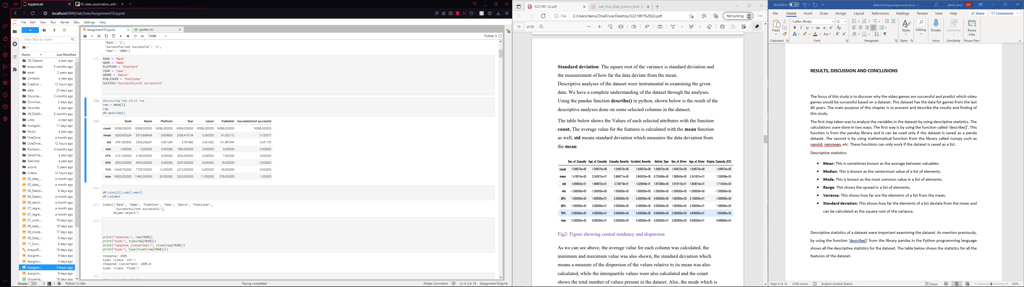

Fig1: Figure showing the descriptive data for the features of the dataset

The table shown above only works if the dataset is saved as a pandas dataset. Also, all the features must be numerical in type. Except for ‘Year,’ all the features had to be transformed from categorical features into numerical features. As seen in the figure, almost every value that composes the descriptive statistics was calculated. The count shows the total amount of rows in the dataset, thus presenting the actual size of the dataset. The dataset was also saved as a list to show the results in the original form. In this form, the only descriptive statistic which can be calculated is the mode. Shown below is the mode for every feature. Based on the results of the descriptive statistics, many things can be discovered, and they will be presented for each feature at a time.

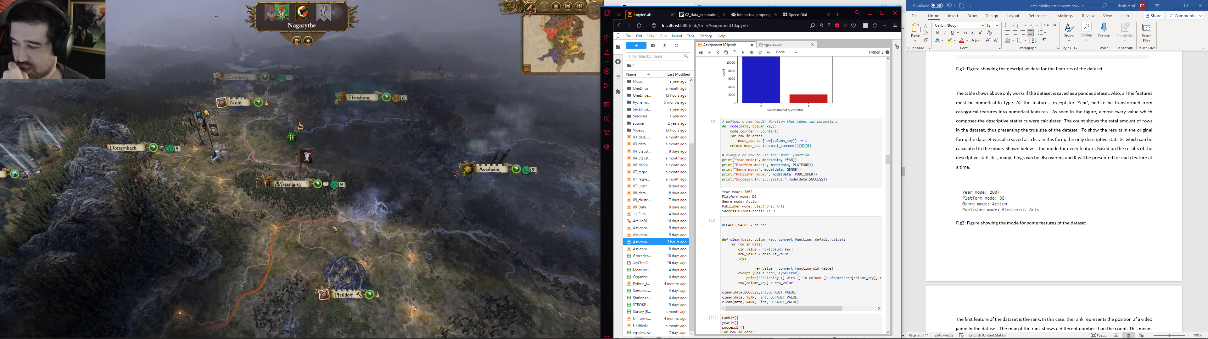

Fig2: Figure showing the mode for some features of the dataset

The first feature of the dataset is the rank. In this case, the rank represents the position of a video game in the dataset. The max of the rank shows a different number than the count. This means that the dataset's author either counted wrong or forgot to introduce video games into the dataset. The next feature on the list is the name. It represents the official name of a video game which can be found in the dataset. The max for the name is different from the count. This can only mean one thing. Some video games in the dataset appear multiple times. A video game can be launched on different platforms. It can be launched in the same year on different platforms or rare cases. It can be launched on different in different years. One example of a video game launched on different platforms is Grand Theft Auto V. (Rockstar North Limited, 2013). Most of the time, it happens when a new generation of consoles is launched, and publishers publish their video games both on an old and new generation of consoles. The next feature is the platform. The max of the feature shows that the video games listed in the dataset were launched on thirty-one platforms. However, not all these platforms are present today. Most of these platforms are not available in the market for years or even decades. Nowadays, video game developers focus on a few platforms. The mode of the feature shows that DS is the most popular platform, which means most of the video games in the dataset were launched on it. The next feature is the year. The min and max of the feature show that the dataset features video games over 40 years, from 1980 until 2020. The mode shows that 2007 has the most video games launched. The next feature is the genre. The max of the feature shows that the video games featured in the dataset can be classified into 12 different genres. The featured mode shows that Action video games are the most popular genre of video games. The next feature in the dataset is the publisher. The max of the feature shows that the dataset features video games published by almost 600 publishers. The featured mode shows that Electronic Arts published the most video games in the dataset. The last feature of the dataset is the successful/unsuccessful. The mode for the feature shows that most of the video games featured in the dataset are unsuccessful.

The next step of the study is to find the distribution of the features to do statistical tests. This can be done by calculating the histogram and plotting a graph with the findings.

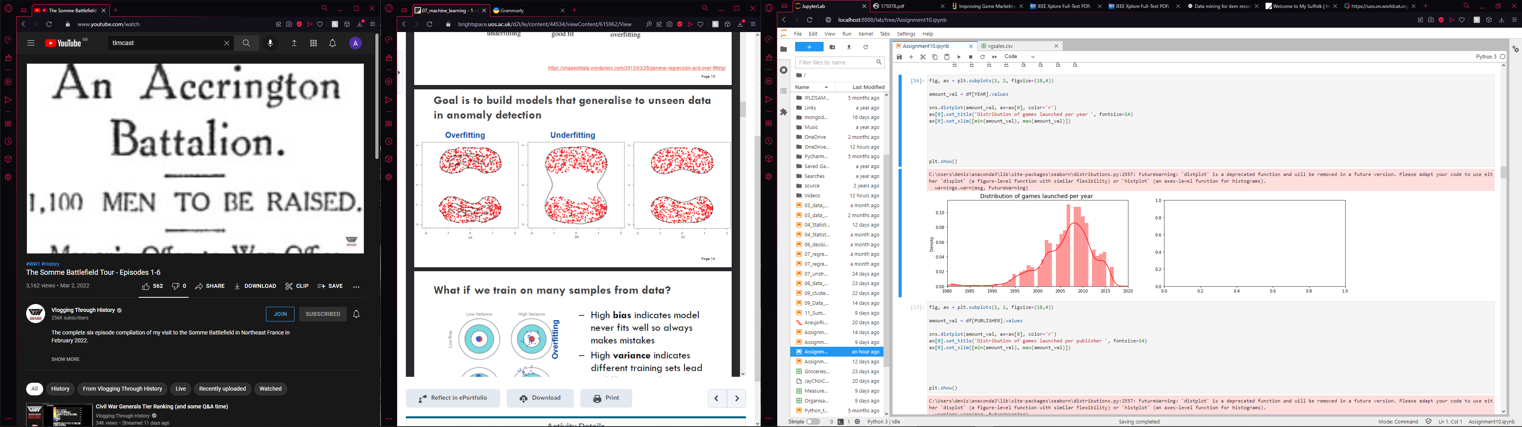

Fig3: Figure showing the distribution of the year attribute

As it can be observed in Fig3, the year feature has a skew distribution. Being the only feature which originally numerical, Fig3 shows the only graph with a distribution which will be taken into consideration when performing the statistical tests.

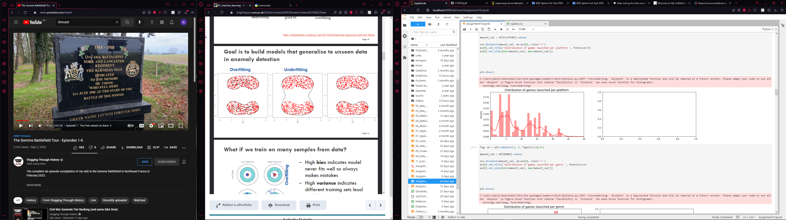

Fig4: Figure showing the distribution of the platform attribute

As it can be observed in Fig4, most videos games were launched on six platforms. These platforms are part of the newer generations of platforms, and with the increasing of number of games launched each year, these platforms get the most amount of attention from developers.

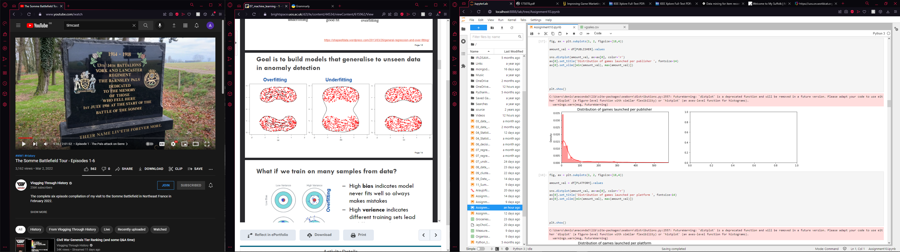

Fig5: Figure showing the distribution of the publisher attribute

As it can be observed in Fig5, most video games launched were publisher by a couple dozen publisher. These publishers have immense power on the market. Thus, it can influence which video game is successful and which does not.

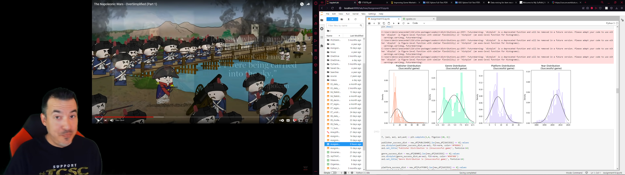

Fig6: Figure showing the of all the features in the successful class

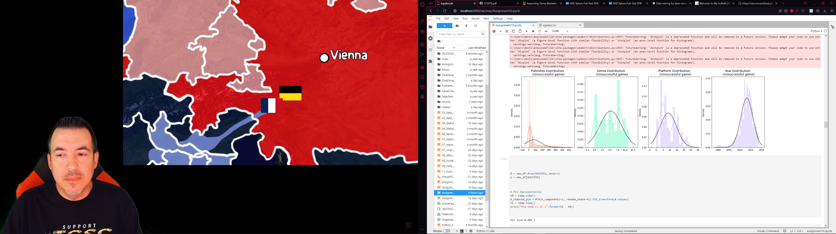

Fig7: Figure showing the of all the features in the unsuccessful class

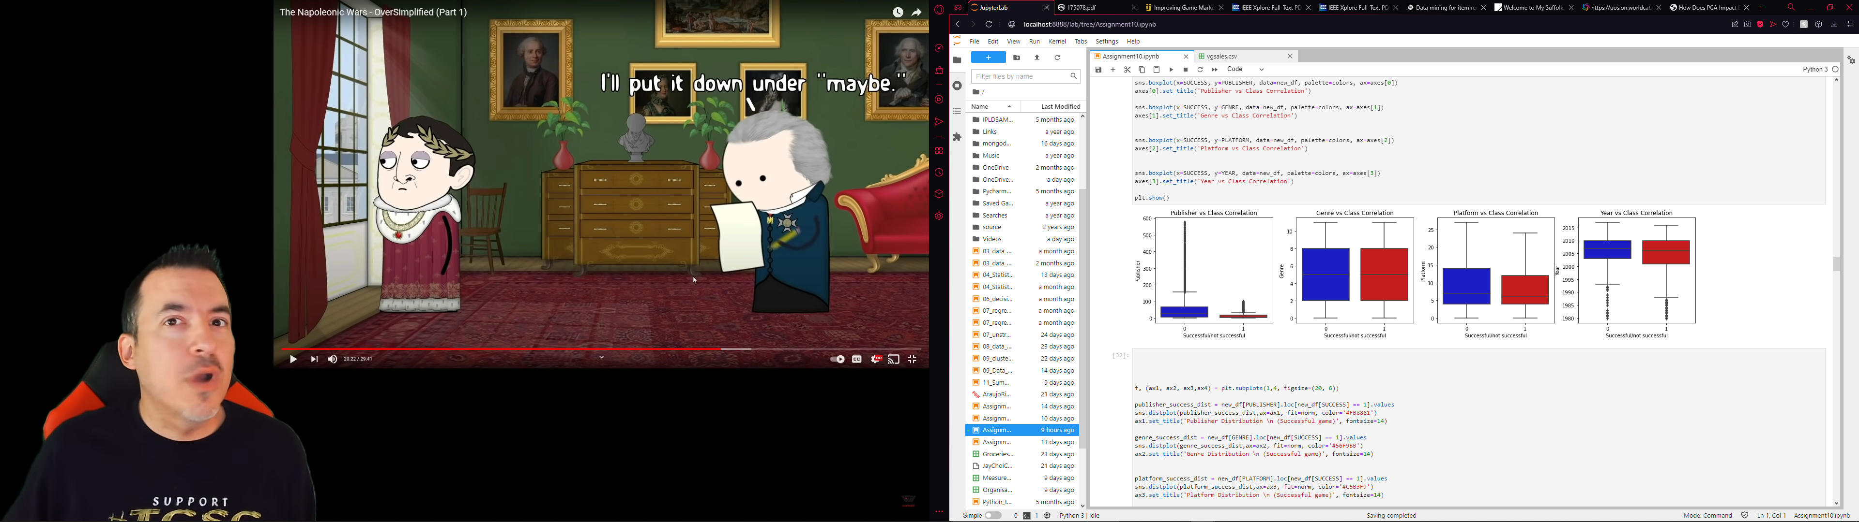

Fig8: Figure showing the of all the features in the unsuccessful class

The next step is to do the statistical tests, it is important to decide which correlation needs to be tested and which hypothesizes could be considered null or alternative.

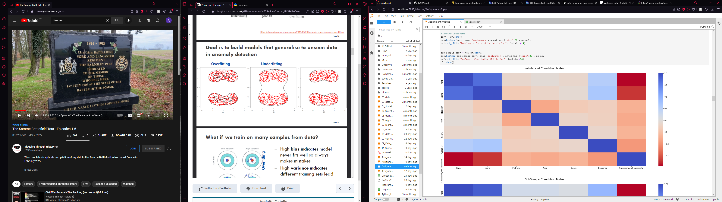

Fig9: Figure showing the correlation matrix before balancing



Fig10: Each feature against class correlation

In the correlation matrix, four correlations are considered necessary in the grand scheme of the study: rank-successful/unsuccessful, rank-name, name-successful/unsuccessful, name-publisher and rank-publisher. Two possible alternative hypotheses could be set: if the publisher affects the rank and the publisher affects the name. In addition, two possible null hypothesises could be set: if rank does not affect successful/unsuccessful and if the name does not affect successful/unsuccessful. Since all the outcome variables are categorical, and the exposure variable includes two or more groups, the statistical test used in this study is the Chi-square test. Based on the results of the tests, in the case of the alternative hypothesizes, the name-publisher correlation passed the test, while the rank-publisher correlation did not. Thus, the former can be considered an alternative hypothesis, while the latter can not be considered an alternative hypothesis. In the case of the null hypotheses, both correlations passed the tests, which means both null hypothesizes are rejected. In the context of the study, both the rank and the name feature do not influence the successful/unsuccessful feature. While doing p-hacking, it was observed that it did not change the alternative hypotheses and null hypotheses.

The next step in the study's progress is to split the data into training and test data for machine learning. Before doing the split, it is essential to balance the data. The chosen ratio between train and test was 80-20 split. The first was used for using for balancing the data was through subsampling.

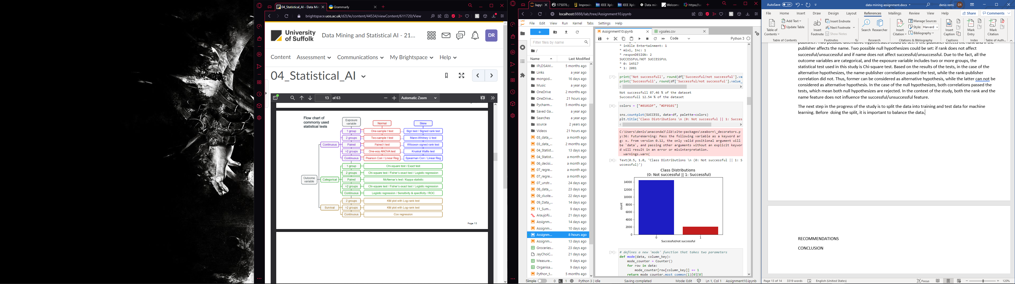

Fig11: Figure showing the class distribution of the data

As presented in Fig11, the data is unbalanced, with 87.46% of the data being classified as unsuccessful, while 12.54% is classified as successful. The first way used for using for balancing the data was through subsampling.

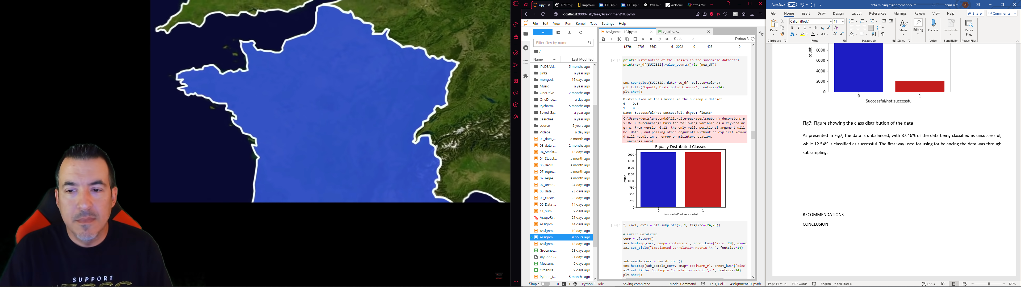

Fig12: Figure showing the class distribution after subsampling

When doing the correlation matrix, there was a chance in the correlation.

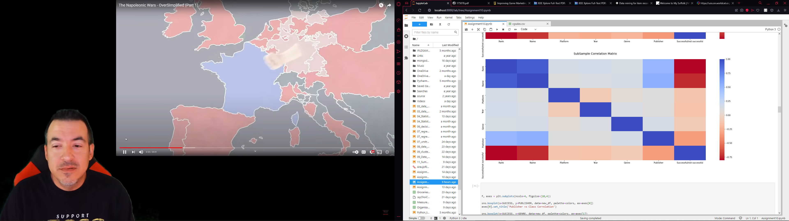

Fig13: Figure showing the correlation matrix after subsampling

Although the dataset has a small number of features, the PCA method should be taken into consideration. PCA, or Principal Component Analysis, us a dimensional reduction method which is used to reduce the number of features in a dataset. (sarahjocrawford.com, n.d.)

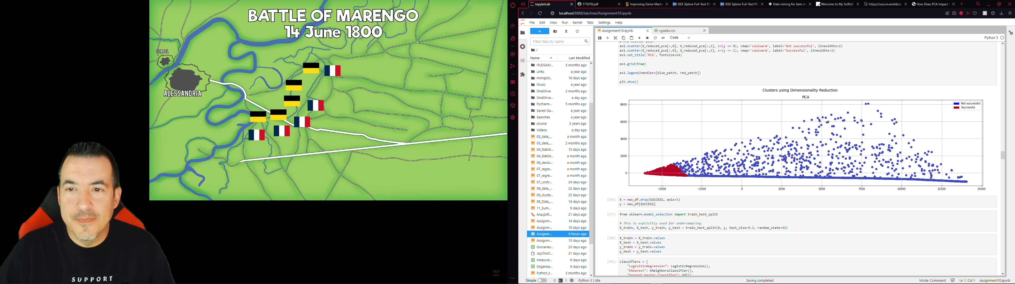

Fig14: PCA of the dataset

As seen in Fig14, the clusters could be divided easily into the classes. For this dataset, an overfitting case can be taken into consideration to separate accurately the classes.

For this study, four machine learning algorithms were used as classifiers. Those were: Logistic Regression, K-Nearest Neighbors, Support Vector Classifier, and Decision Tree Classifier. Logistical Regression is an essential statistical and data mining technique for analyzing and classiﬁcation of binary and proportional response data sets. (Maalouf, 2011). K-Nearest Neighbors is a method that is non-parametric used in classifications. The principle behind it is that available data are arranged in a space defined by selected features. (Chanal, et al., 2021) Support Vector Classifier is a version of Support Vector Machine, or SVM, which is used when dealing with classification problems. SVM is “a training algorithm for learning classification and regression rules from data.” (Burbidge & Buxton, n.d.) And lastly, Decision Trees Classifiers is a type of data mining technique that builds models” un the form of the tree structure and hence belong to the supervised form of learning” (Sharma, 2021)

As mentioned previously, the data was split into training and testing data with a ratio of 80-20. Before introducing the training data into the machine learning algorithms, the data had to be balanced. In this case, the data was balanced through under-sampling. When using a machine learning algorithm, the first thing to calculate is to calculate the training score. For Logistic Regression, the training score was 100.0%. For K-Nearest Neighbor, the training score was 100.0%. For the Support Vector Classifier, the training score was 98.0%. For the Decision Tree Classifier, the training score was 100.0%. In Fig12, the PCA shows that a case of overfitting is possible in the dataset of this study. The next step is to calculate the cross-validation score for all four classifiers. Cross-validation “can be defined as the use of one or more statistical techniques to validate the reliability of the prediction of the model” (Maurya, 2020). The Cross-validation scores for the classifiers are as follows: 99.88% for Logistic Regression, 99.82% for K-Nearest Neighbor, 99.97% for Support Vector Classifier, and 99.97% for Decision Tree Classifier. The learning curve can be plotted with the training and cross-validation scores calculated. Fig15, Fig16, Fig 17, Fig18 shows all the learning curves of all four of the classifiers used in this study.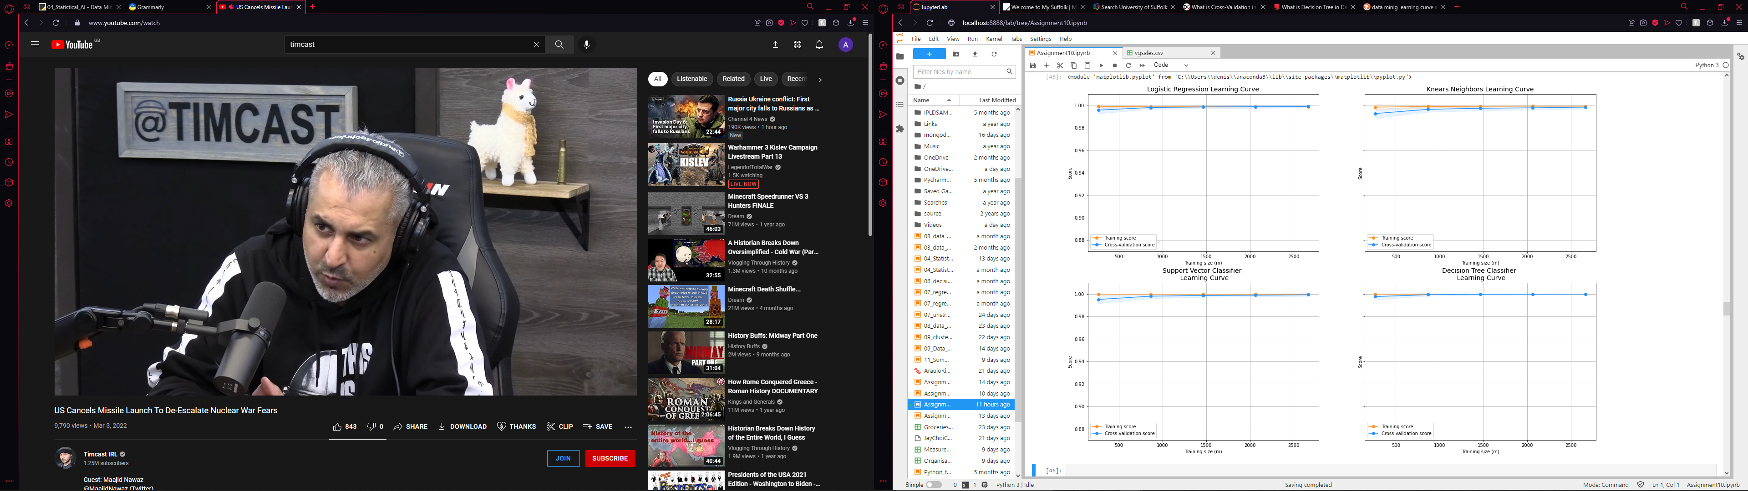

Fig15: Learning curve for the Logistic Regression



Fig16: Learning curve for the K-Near Neighbor



Fig17: Learning curve for the Support Vector Classifier



Fig18: Learning curve for the Decision Tree Classifier

The next step in the process is to calculate the ROC of the classifiers. An ROC, or Receiver Operating Characteristics, is a “technique for visualizing, organizing and selecting classifiers based on their performance” (Fawcett, 2003). ROC is calculated based on the ration between the true positive rate and false positive rate.

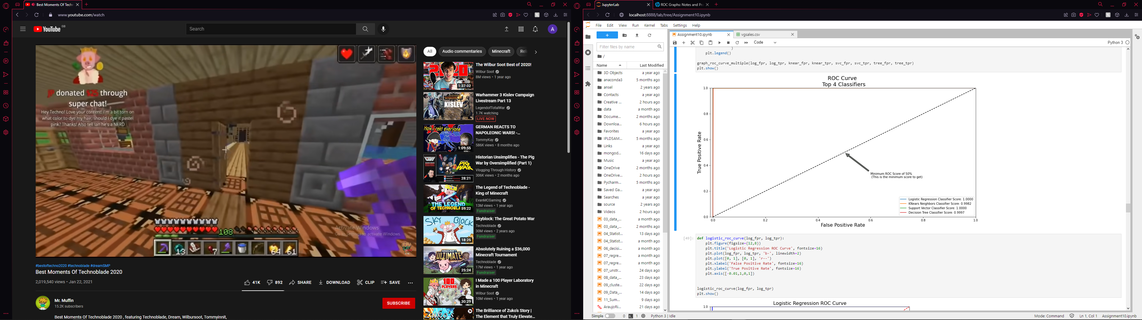

Fig19: ROC for all the classifiers

In the overfitting case with cross-validation where random under sampling was used for balancing the data, the result of the model is as follows: recall score is 1.00, the precision score is 1.00, the f1 score is 1.00 and the accuracy score is 1.00. Based on these results, the precision-recall curve can be plotted, with Fig 20 showing the result:

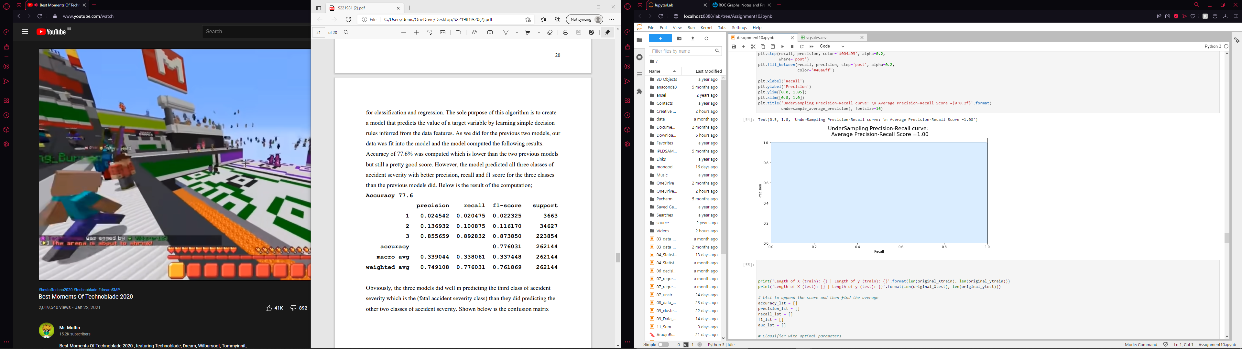

Fig20: Under sampling precision-recall curve

All the previously presented results were calculated using under-sampling as the balancing method for this study's dataset. To see if different balancing methods influence the model, over-sampling was also used as a balancing method. The oversampling type method of choice was SMOTE. SMOTE or Synthetic Minority Oversampling Technique "preprocessing algorithm is considered 'de facto' standard in the framework of learning from imbalanced data ." (Fernandez, et al., 2018) In the overfitting case with cross-validation where SMOTE was used for balancing the data, the result of the model is as follows: recall score is 0.99, the precision score is 0.99, the f1 score is 0.99, and the accuracy score is 0.99. Based on these results, the precision-recall curve can be plotted, with Fig 21 showing the result:

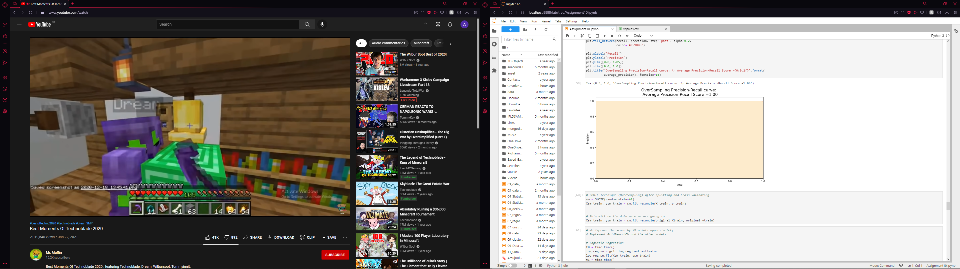

Fig21 Oversampling precision-recall curve

In the case of SMOTE, the results of the model were calculated for each class, with Fig.22 showing the findings:

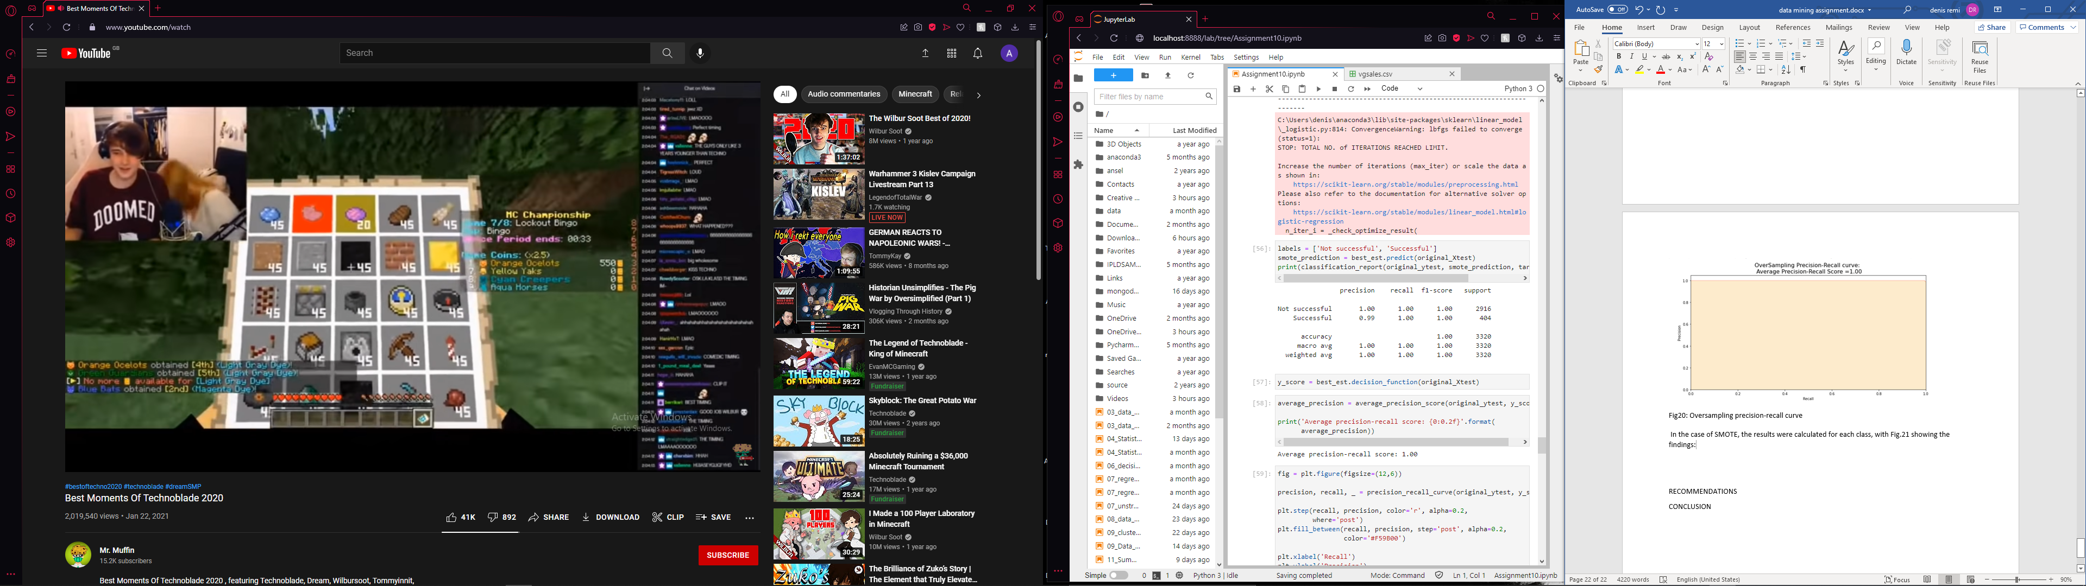

Fig22: The results of the model based on the class

Before calculating the resorts of the model per class for each classifier, it is important to visualize the parameters which take place in the calculations. By using a confusion matrix, the parameters would be visualized. Fig23, Fig24, Fig25 and Fig26 shows the parameter for each classifier:

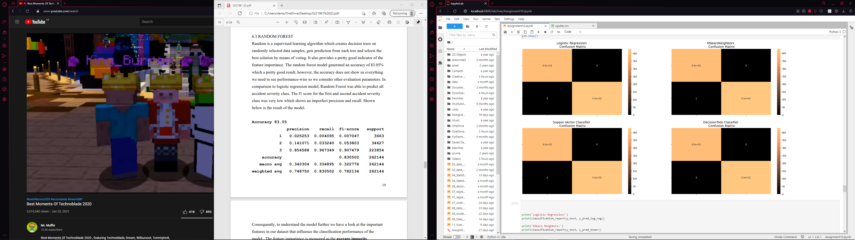

Fig23: Confusion matrix for Logistic Regression



Fig24: Confusion matrix for K-Near Neighbors



Fig25: Confusion matrix for Support Vector Classifier



Fig26: Confusion matrix for Decision Tree Classifier

With the parameters visualized, the next step to take is to calculate the results of the model for every classifier.

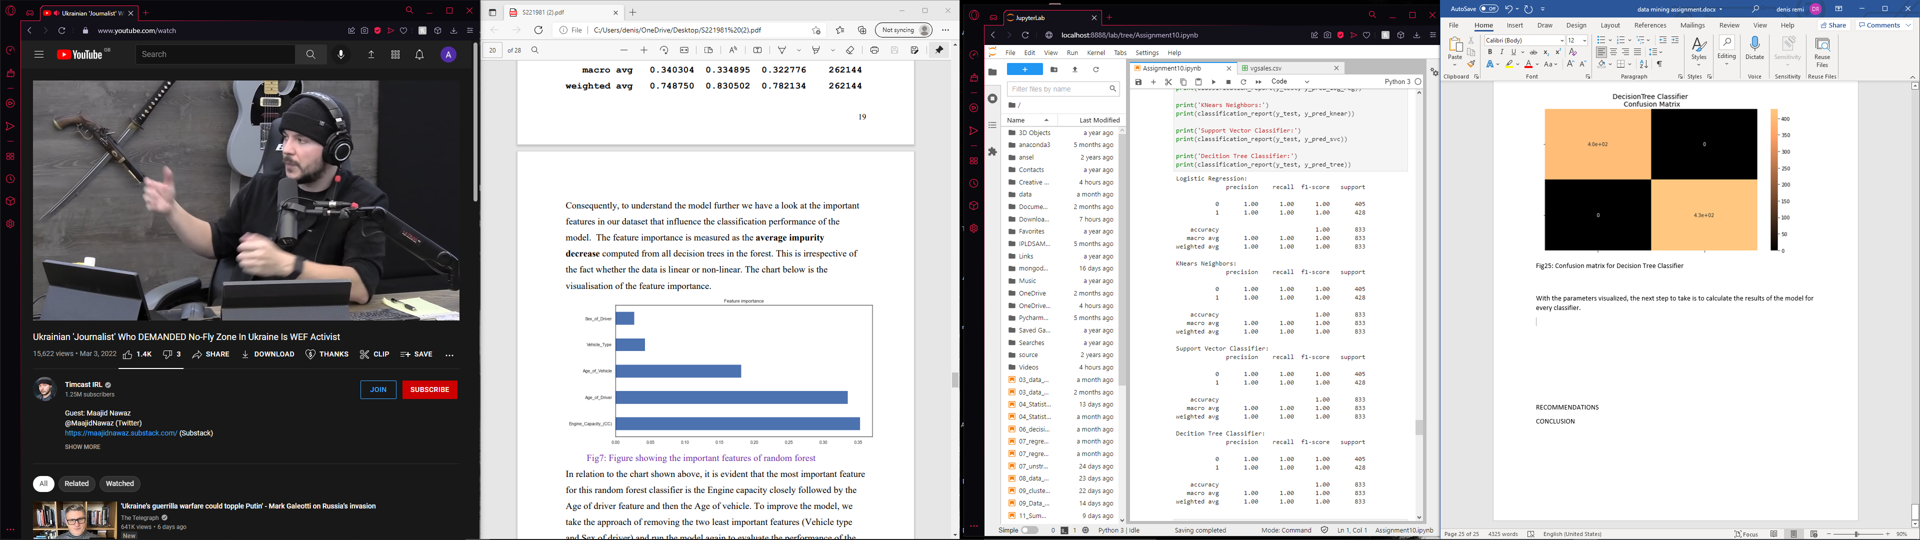

Fig27 The result of the model for every classifier based on class

Based on the results of the model presented above, no matter which classier is used in the model, they all show the same results.

The final comparison made in the study is between the accuracy scores of the model which used random under sampling and the model which used SMOTE as a method of balancing of the database.

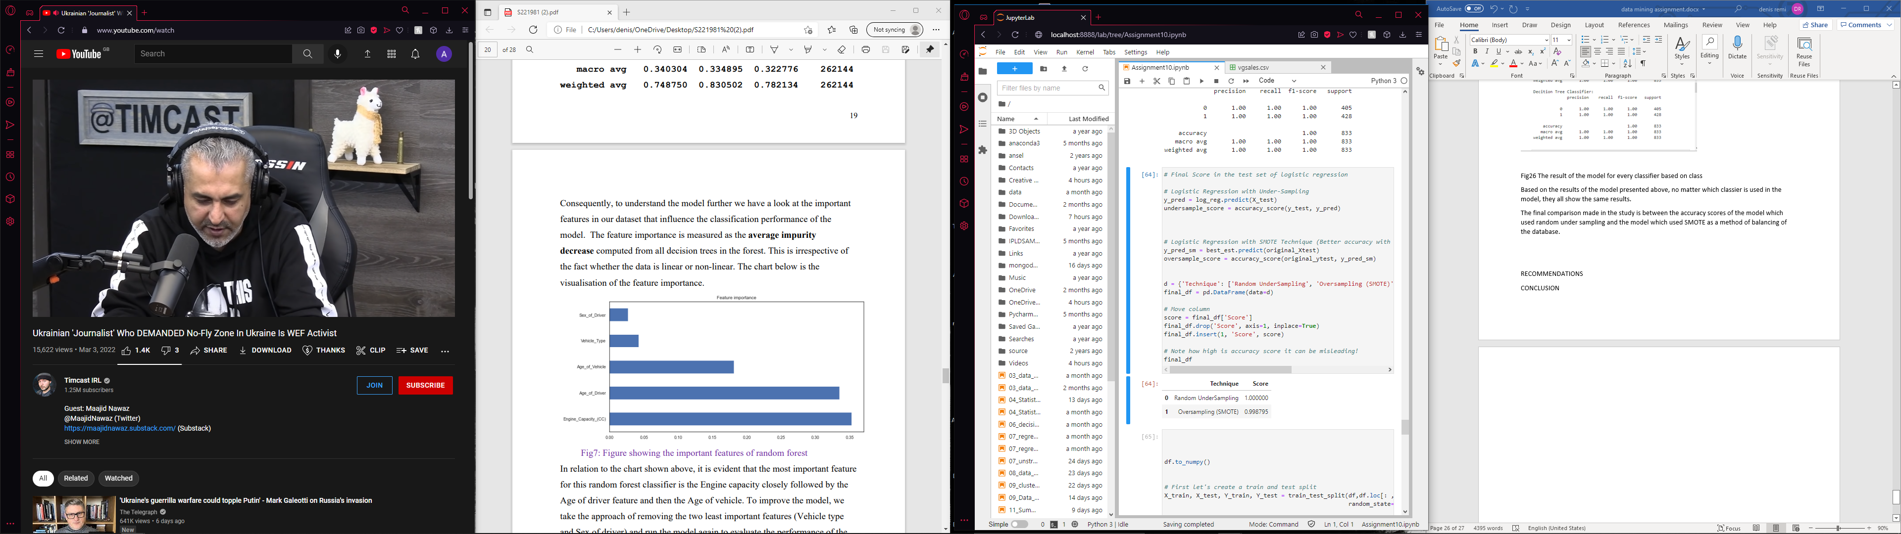

Fig28 The accuracy score for the two balancing methods

Fig28 shows that the model which used under sampling had a higher accuracy score then the model which used SMOTE, although the difference is not large.

Although the model is finished and all the results were calculated, one more thing was tested. A different form of Decision Tree Classifier was used to test the model. The difference between them is that the former is the function that calls the classifier previously mentioned is a function from sklearn library. At the same time, the latter is a function coded in the study. Also, in the latter version, the depth of the tree can be set. Therefore, the depth of the tree can be lower than the number of features in the dataset. One observation from the features that could influence the tree's depth is the relationship between publisher and platform. Some publishers also own the intellectual rights to a platform, which means they would publish their video games only on those platforms. For example, Nintendo owns the Wii, DS, Wii U, etc. (Nintendo Wiki, n.d.)

**7. RECOMMENDATIONS**

Including more features in the dataset could help improve the realism of the predictions. Although the number of machine learning algorithms is sufficient to develop such predictions, diversifying the algorithms would help deal with extensive databases in the number of features.

**8. CONCLUSION**

The dataset used in this study represents just the tip of the iceberg for the video games industry. From the features of the original version, the important ones were kept, the least important ones were deleted, and one was modified to go following the study. Different machine learning algorithms were trained to predict the two classes. Those classes have been successful and unsuccessful in video games.

# References

1. Anagnostou, K. & Maragoudakis, M., 2009. *Data Mining for Player Modeling in Videogames.* s.l., IEEE Xplore.
2. Araujo, V., Rios, F. & Parra, D., 2019. Data mining for item recommendation in MOBA games. *RecSys '19: Proceedings of the 13th ACM Conference on Recommender Systems*, September, p. 393–397.
3. Burbidge, R. & Buxton, B., n.d. *An Introduction to Support Vector Machines for Data.* [Online]   
   Available at: https://www.cc.gatech.edu/classes/AY2008/cs7641_spring/handouts/yor12-introsvm.pdf  
   [Accessed 27 February 2022].
4. Chanal, D. et al., 2021. *Online Diagnosis of PEM Fuel Cell by Fuzzy C-Means Clustering.* [Online]   
   Available at: https://www.sciencedirect.com/science/article/pii/B9780128197233000998  
   [Accessed 28 February 2022].
5. Fawcett, T., 2003. *ROC Graphs: Notes and Practical Considerations.* [Online]   
   Available at: https://www.hpl.hp.com/techreports/2003/HPL-2003-4.pdf  
   [Accessed 28 February 2022].
6. Fernandes, B., Ansari, N., Deasai, H. & Dias, P., 2021. Improving Game Marketing using Classification. *International Journal of Engineering Research & Technology (IJERT),* 9(3), pp. 334-339.
7. Fernandez, A., Garcia, S., Herrera, F. & Crawla, N. V., 2018. SMOTE for Learning from Imbalanced Data: Progress and. *Journal of Artificial Intelligence Research 61,* pp. 863-905.
8. Grus, J., 2015. *Data Science from Scratch.* Sebastopol: 5 O’Reilly Media.
9. Maalouf, M., 2011. Logistic regression in data analysis: An overview. *nternational Journal of Data Analysis Techniques and Strategies,* 3(3), pp. 281-299.
10. Marcoux, J. & Selouani, S.-A., 2009. *A Hybrid Subspace-Connectionist Data Mining Approach for Sales Forecasting in the Video Game Industry.* s.l., IEEE Xplore.
11. Maurya, R., 2020. *What is Cross-Validation in data mining.* [Online]   
    Available at: https://digitalgyan.org/what-is-cross-validation/  
    [Accessed 28 February 2022].
12. Mitchell, T. M., 1999. Machine Learning and Data Mining. *Communications of the ACM,* 42(11), pp. 30-36.
13. Nintendo Wiki, n.d. *List of Nintendo systems.* [Online]   
    Available at: https://nintendo.fandom.com/wiki/List_of_Nintendo_systems  
    [Accessed 28 February 2022].
14. Oxford Reference, n.d. *Statistics.* [Online]   
    Available at: https://www.oxfordreference.com/view/10.1093/acref/9780192629500.001.0001/acref-9780192629500-e-463  
    [Accessed 26 February 2022].
15. Parker, L., 2011. *The Rise of the Indie Developer.* [Online]   
    Available at: https://www.gamespot.com/articles/the-rise-of-the-indie-developer/1100-6298425/  
    [Accessed 24 February 2022].
16. Piant, L., 2021. *Why Digital Games Could Totally Dominate Physical Formats In Just a Few Years.* [Online]   
    Available at: https://www.ign.com/articles/why-digital-sales-could-totally-dominate-physical-formats-in-just-a-few-years  
    [Accessed 25 February 2022].
17. Rockstar North Limited, 2013. *Grand Theft Auto V.* s.l.:Rockstar Games.
18. sarahjocrawford.com, n.d. *How Does PCA Impact Data Mining Activity?.* [Online]   
    Available at: https://sarahjocrawford.com/how-does-pca-impact-data-mining-activity/  
    [Accessed 28 February 2022].
19. Sharma, R., 2021. *What is Decision Tree in Data Mining? Types, Real World Examples & Applications.* [Online]   
    Available at: https://www.upgrad.com/blog/what-is-decision-tree-in-data-mining/  
    [Accessed 27 February 2022].
20. Siqueira, E. S., Rodrigues, G. N., Castanho, C. D. & Jacobi, R. P., 2017. *A Data Analysis of Player in World of Warcraft using Game Data Mining.* Curitiba, XVI SBGames.